Case Study 08: Automated Parking Lot Fee Calculation System

1. Problem Statement

Develop a Python program to calculate the parking charges for vehicles parked in a commercial lot based on vehicle category and duration of stay. The program captures the vehicle type (car or bike) and integer timestamps representing entry and exit hours within a 24-hour military clock notation (0 to 23). It must validate user entries, resolve overnight stays crossing midnight, treat matching entry and exit timestamps as a full 24-hour duration, apply hourly rates with a daily maximum price cap based on vehicle category, and print the calculated parking fee.

2. Objectives

- To validate string categories and numerical time ranges within 24-hour format boundaries ($0≤\text{hour}≤23$).

- To implement rollover time arithmetic to handle parking periods spanning across midnight.

- To utilize tuple unpacking with conditional ternary operators to configure vehicle-specific fee rates and daily caps.

- To compute final billing by clamping total hourly costs to maximum ceiling charges using Python's min() function.

3. Assumptions

- Only two vehicle types are supported: "car" and "bike" (processed case-insensitively).

- Valid hours are integers from 0 to 23 inclusive.

- If exit_time == entry, the program assumes the vehicle occupied the space for a full 24-hour parking cycle.

- If exit_time < entry, the vehicle parked overnight crossing midnight, calculated as $24-\text{entry}+\text{exit_time}$.

- Pricing structure:

  - Car: Rs. 30 per hour, capped at a maximum daily ceiling of Rs. 200.

  - Bike: Rs. 15 per hour, capped at a maximum daily ceiling of Rs. 100.

4. Algorithm

- Step 1: Start the program.

- Step 2: Prompt and read vehicle string, convert to lowercase using .lower().

- Step 3: Prompt and read integer values for entry and exit_time.

- Step 4: Validate inputs: check if vehicle not in ("car", "bike") or not (0 <= entry <= 23 and 0 <= exit_time <= 23). If invalid, print "Invalid input" and proceed to Step 10.

- Step 5: Compute duration:

  - If exit_time >= entry, set duration = exit_time - entry.

  - Else, set duration = 24 - entry + exit_time.

- Step 6: If duration == 0, reassign duration = 24.

- Step 7: Set hours = int(duration) if duration == int(duration) else int(duration) + 1.

- Step 8: Assign (rate, limit) = (30, 200) if vehicle == "car", else (15, 100).

- Step 9: Calculate payable fee: fee = min(hours * rate, limit).

- Step 10: Display "Parking hours charged: <hours>" and "Parking fee: Rs. <fee>".

- Step 11: Stop the program.

5. Flowchart Logic / Diagram

Plaintext
[Start]
│
▼
[Input vehicle, entry,
exit_time]
│
▼
<Valid vehicle and hours 0-23?>
│ │
(No) │ │ (Yes)
▼ ▼
[Print "Invalid"] <exit_time >= entry?>
│ │ │
│ (Yes)│ │(No)
│ ▼ ▼
│ [duration = [duration =
│ exit - entry] 24 - entry + exit]
│ │ │
│ └────────┬────────┘
│ │
│ ▼
│ <duration == 0?>
│ │ │
│ (Yes)│ │(No)
│ ▼ ▼
│ [duration = 24] [Keep duration]
│ │ │
│ └──────┬─────┘
│ │
│ ▼
│ [hours = int(duration)]
│ │
│ ▼
│ <vehicle == "car"?>
│ │ │
│ (Yes)│ │(No)
│ ▼ ▼
│ [rate=30, cap=200] [rate=15, cap=100]
│ │ │
│ └───────┬───────┘
│ │
│ ▼
│ [fee = min(hours*rate, cap)]
│ [Print hours and fee]
│ │
└─────────────────────┴───────┐
▼
[End]

6. Pseudocode

Plaintext
BEGIN
PRINT "Vehicle (car/bike): "
READ vehicle_input
SET vehicle = TO_LOWERCASE(vehicle_input)

PRINT "Entry hour (0-23): "
READ entry
PRINT "Exit hour (0-23): "
READ exit_time

IF vehicle NOT IN ("car", "bike") OR NOT (0 <= entry <= 23 AND 0 <= exit_time <= 23) THEN
PRINT "Invalid input"
ELSE
IF exit_time >= entry THEN
SET duration = exit_time - entry
ELSE
SET duration = 24 - entry + exit_time
END IF

IF duration == 0 THEN
SET duration = 24
END IF

SET hours = INTEGER(duration)

IF vehicle == "car" THEN
SET rate = 30
SET limit = 200
ELSE
SET rate = 15
SET limit = 100
END IF

SET fee = MINIMUM(hours * rate, limit)

PRINT "Parking hours charged:", hours
PRINT "Parking fee: Rs.", fee
END IF
END

7. Python Source Code

Python
# Automated Parking Lot Fee Calculation System

# Read input data and normalize vehicle string
vehicle = input("Vehicle (car/bike): ").lower()
entry = int(input("Entry hour (0-23): "))
exit_time = int(input("Exit hour (0-23): "))

# Validate vehicle category and 24-hour military clock range
if vehicle not in ("car", "bike") or not (0 <= entry <= 23 and 0 <= exit_time <= 23):
print("Invalid input")
else:
# Compute elapsed parking duration handling overnight stays
duration = exit_time - entry if exit_time >= entry else 24 - entry + exit_time

# Treat identical entry/exit time as full 24-hour cycle
if duration == 0:
duration = 24

# Quantize duration into billable hours
hours = int(duration) if duration == int(duration) else int(duration) + 1

# Configure rates and maximum daily cap by vehicle category
rate, limit = (30, 200) if vehicle == "car" else (15, 100)

# Compute payable fee with cap protection
fee = min(hours * rate, limit)

# Display billing report
print("Parking hours charged:", hours)
print("Parking fee: Rs.", fee)

8. Test Cases

Test Case ID | Input Given | Expected Output | Actual Output | Status
TC_01 (Car Normal Hours) | Vehicle = car  Entry = 9  Exit = 14 | Parking hours charged: 5  Parking fee: Rs. 150 | Parking hours charged: 5  Parking fee: Rs. 150 | Pass
TC_02 (Car Hits Max Cap) | Vehicle = car  Entry = 8  Exit = 18 | Parking hours charged: 10  Parking fee: Rs. 200 | Parking hours charged: 10  Parking fee: Rs. 200 | Pass
TC_03 (Bike Overnight Stay) | Vehicle = bike  Entry = 22  Exit = 4 | Parking hours charged: 6  Parking fee: Rs. 90 | Parking hours charged: 6  Parking fee: Rs. 90 | Pass
TC_04 (Full 24-Hour Cycle) | Vehicle = bike  Entry = 10  Exit = 10 | Parking hours charged: 24  Parking fee: Rs. 100 | Parking hours charged: 24  Parking fee: Rs. 100 | Pass
TC_05 (Invalid Input) | Vehicle = truck  Entry = 10  Exit = 14 | Invalid input | Invalid input | Pass

9. Output Screenshots

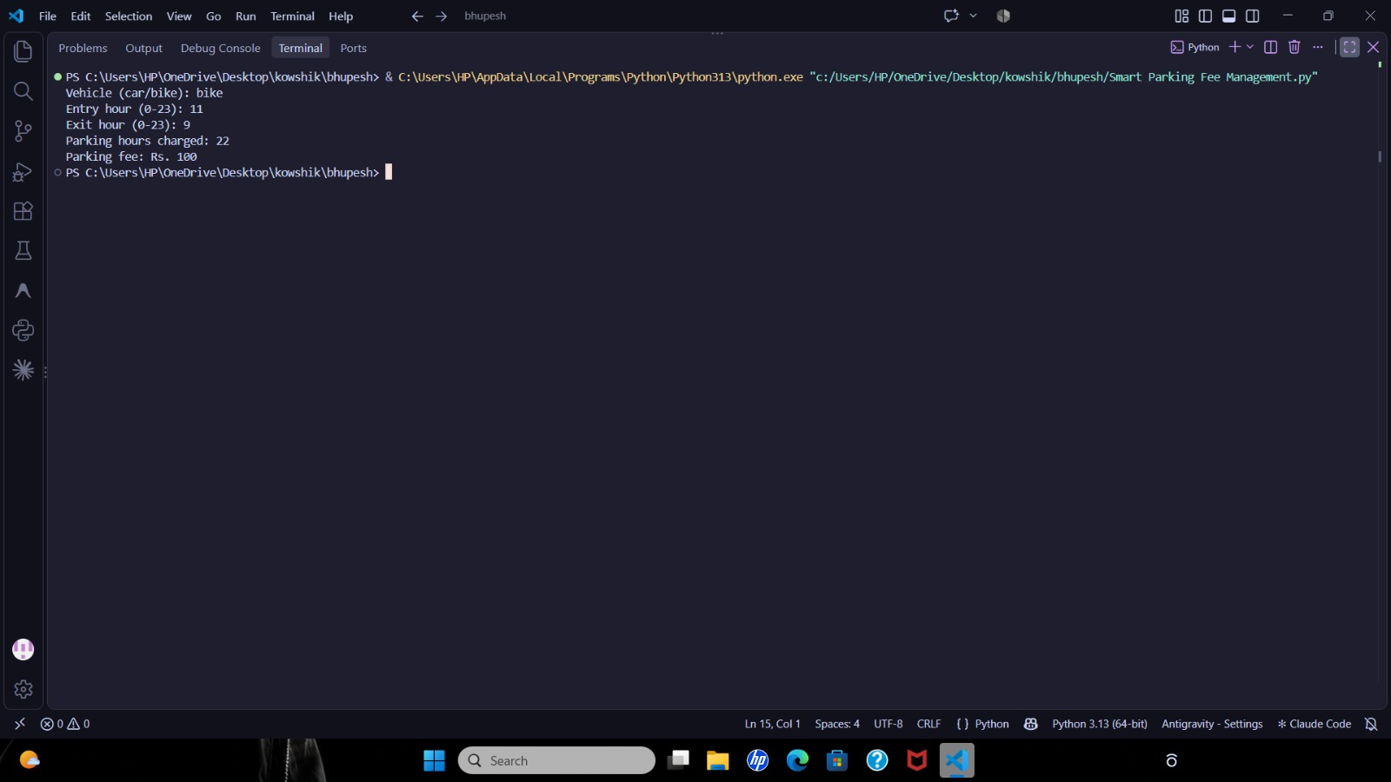

10. Conclusion

The Automated Parking Lot Fee Calculation System was implemented and verified successfully. The script demonstrates the application of composite conditional boundary validation, 24-hour circular modulo time math, tuple unpacking using ternary conditions, and ceiling caps using the built-in min() function.

